1



**Project Report**

**On**

**SCUT-Library**

**Management**

**System**

**Submitted By**

**Student Name ：**小龙 Alshaebi Abdulrahman Khaled Awadh.

**Student ID：**201969990106.

**Class :** Database.

**Teacher :** 汪秀敏 / Wang Xiumin**.**

2

# CERTIFICATE

Certified that this is a bonafide record of the project work titled

**SCUT-LIBRARY MANAGEMENT SYSTEM**

**Done By:**

**小龙 Alshaebi Abdulrahman Khaled Awadh**

in the year 2021

# ACKNOWLEDGEMENT

I take this occasion to thank God, almighty for blessing me with his grace and taking  me endeavor to a successful culmination. I also extend my sincere and heartfelt thanks to my  teacher 汪秀敏. I would

like to thank my friends and family for the support and encouragement they have given me during the course of my work.

## TABLE OF CONTENTS

ABSTRACT 5

1. **INTRODUCTION**  **6**
   1. PROJECT AIMS AND OBJECTIVES 6
   2. BACKGROUND OF PROJECT 6
2. **SYSTEM ANALYSIS**  **7**
   1. SOFTWARE REQUIREMENT SPECIFICATION 9
   2. SOFTWARE TOOL USED 12
3. **SYSTEM DESIGN** **15**
   1. TABLE DESIGN 15
   2. DATA FLOW DIAGRAM’S 21
4. **SYSTEM IMPLEMENTATION** **24**
   1. SCREEN SHOTS 24
5. **SYSTEM TESTING** **32**
   1. UNIT TESTING 32
   2. INTEGRATION TESTING 34
6. **CONCLUSION**  35

Abstract:

SCUT Online Library Management System is a system which maintains the information about the books present in the library, their authors, the users of library to whom books are issued, library staff and all. This is very difficult to organize manually. Maintenance of all this information manually is a very complex task. Owing to the advancement of technology, organization of an Online Library becomes much simpler. The Online Library Management has been designed to computerize and automate the operations performed over the information about the users, book issues and returns and all other operations. This computerization of the library helps in many instances of its maintenance. It reduces the workload of management as most of the manual work done is reduced

**CHAPTER 1**

**INTRODUCTION**

This chapter gives an overview about the aim , objectives ,background and operation environment of the system.

### 1.1 PROJECT AIMS AND OBJECTIVES

The project aims and objectives that will be achieved after completion of this project are discussed in this subchapter. The aims and objectives are as follows:

* User Login & admin Login.
* Online book searching. 
* User Registration.
* A search column to search availability of books. 
* Readers who do not return books in time, will have bad records. 
* Add, Update, Delete students details. 
* Add, Update, Delete author & publisher details.
* Readers can search books, and borrow books if no bad records. 
* Readers can modify personal information, except their IDs.
* Administrators can view all transaction records.
* Admin can manage users active deactive users accounts ,Issues books, delete users, and when the user return the book can active thier accounts as well.
* An Admin login page where admin can add, edit, publish, remove books.
* Library owns many books, there will be several copies of the same book.
* Book can be borrowed for a particular period.

#### 1.2 BACKGROUND OF PROJECT

SCUT-Library Management System is a website which refers to library systems which are generally small or medium in size. It is used by librarian to manage the library using a computerized system where he/she can add new books.

Books and student maintenance modules are also included in this system which would keep track of the students using the library and also a detailed description about the books a library contains. With this computerized system there will be no loss of book record or member record which generally happens when a non computerized system is used.

All these modules are able to help librarian to manage the library with more convenience and in a more efficient way as compared to library systems which are not computerized.

**CHAPTER 2**

### SYSTEM ANALYSIS

In this chapter, I will discuss and analyze about the developing process of Library Management System including software requirement specification (SRS) and comparison between existing and proposed system . The functional and non functional requirements are included in SRS part to provide complete description and overview of system requirement before the developing process is carried out. Besides that, existing vs proposed provides a view of how the proposed system will be more efficient than the existing one.

#### 2.1 SOFTWARE REQUIREMENT SPECIFICATION

**2.1.1 GENERAL DESCRIPTION**

PRODUCT DESCRIPTION:

Library Management System is a computerized system which helps

user(librarian) to manage the library daily activity in electronic format. It reduces

the risk of paper work such as file lost, file damaged and time consuming.

It can help user to manage the transaction or record more effectively and time-

saving.

#### 2.1.2 SYSTEM OBJECTIVES

* Improvement in control and performance 

  The system is developed to cope up with the current issues and problems of library    .The system can add user, validate user and is also bug free. 

* Save cost 

After computerized system is implemented less human force will be required to maintain the library thus reducing the overall cost. 

 

* Save time 

Librarian is able to search record by using few clicks of mouse and few search keywords thus saving his valuable time. 

 

#### 2.1.3 SYSTEM REQUIREMENTS

2.1.3.1 NON FUNCTIONAL REQUIREMENTS

  • Product Requirements 

#####   EFFICIENCY REQUIREMENT 

When a library management system will be implemented librarian and user will easily acess library as searching and book transaction will be very faster . 

##### RELIABILITY REQUIREMENT

The system should accurately performs member registration ,member validation , report generation, book transaction and search

##### USABILITY REQUIREMENT

The system is designed for a user friendly environment so that student and staff of library can perform the various tasks easily and in an effective way.

##### ORGANIZATIONAL REQUIREMENT IMPLEMENTATION REQUIREMNTS

* In implementing whole system it uses html in front end with ASP.NET as server side scripting language which will be used for database connectivity and the backend ie the database part is developed using SQL Server Management Studio (SSMS).

.

2.1.3.2 FUNCTIONAL REQUIREMENTS

1. NORMAL USER

1.1 USER LOGIN

###### Description of feature

This feature used by the user to login into system. They are required to enter user id and password before they are allowed to enter the system .The user id and password will be verified and if invalid id is there user is allowed to not enter the system.

###### Functional requirements

-user id is provided when they register

-The system must only allow user with valid id and password to enter the system

-The system performs authorization process which decides what user level can acess to.

-The user must be able to logout after they finished using system.

##### 1.2 REGISTER NEW USER

Description of feature

This feature can be performed by all users to register new user to create account.

###### Functional requirements

-System must be able to verify information

-System must be able to delete information if information is wrong

##### 1.3 REGISTER NEW BOOK

Description of feature

This feature allows to add new books to the library

###### Functional requirements

-System must be able to verify information.

-System must be able to enter number of copies into table.

- System must be able to not allow two books having same book id.

1.5 SEARCH BOOK

##### DESCRIPTION OF FEATURE

This feature is found in book maintenance part . we can search book based on book id , book name , publication or by author name.

###### Functional requirements

* System must be able to search the database based on select search type

* System must be able to filter book based on keyword enterd

* System must be able to show the filtered book in table view

###### Functional requirements

-System should be able to add detailed information about events .

-System should be able to display information on notice board available in the homepage of site

#### 2.1.4 SOFTWARE AND HARDWARE REQUIREMENTS

This section describes the software and hardware requirements of the system

##### 2.1.4.1 SOFTWARE REQUIREMENTS

 

* Database SQL Server Management Studio (SSMS) is used as database as it easy to maintain and retrieve records by simple queries which are in English language which are easy to understand and easy to write. 

 

* Development tools and Programming language- Bootstraip is used to write the whole code and develop webpages with css, java script for styling work and C# for sever side scripting. 

**Existing System:**

* Early days Libraries are managed manually. It required lot of time to record or to retrieve the details. The employees who have to record the details must perform their job very carefully. Even a small mistake would create a lot of problems. Security of information is very less. Report generations of all the information is very tough task.
* Maintenance of Library catalogue and arrangement of the books to the catalogue is very complex task. In addition to its maintenance of member details, issue dates and return dates etc. manually is a complex task.
* All the operations must be performed in perfect manner for the maintenance of the library with out any degradation which may finally result in the failure of the entire system.

**Proposed System:**

To solve the inconveniences as mentioned in the existing system, an **Online Library** is proposed. The proposed system contains the following features:

* + The students will register them through Online
  + Individually each member will have his account through which he/she can access the information he/she needs.
  + Book details like authors, number of copies totally maintained by library, present available number of books, reference books, non-reference books etc. all this information can be made handy.
  + Regarding the members designation, number of books was issued.
  + Issue dates and returns of each member is maintained separately and list them to the red list if there is any delay in returning the book.
  + Administrator can add, update the books.
  + Time consuming is low, gives accurate results, reliability can be improved with the help of security.

##### **2.3** **SOFTWARE TOOLS USED**

The whole Project is divided in two parts the front end and the back end.

###### 2.3.1 Front end

The front end is designed using of Bootstrap which contains html & CSS and Java script.

 HTML- **HTML**or**Hyper Text Markup Language**is the main markuplanguage for creating web pages and other information that can be displayed in a web browser.HTML is written in the form of HTML elements consisting of *tags* enclosed in angle brackets (like <html>), within the web page content. HTML tags most commonly come in pairs like <h1> and </h1>, although some tags represent *empty elements* and so are unpaired, for example <img>. The first tag in a pair is the *start tag*, and the second tag is the *end tag* (they are also called *opening tags* and *closing tags*). In between these tags web designers can add text, further tags, comments and other types of text-based content. The purpose of a web browser is to read HTML documents and compose them into visible or audible web pages. The browser does not display the HTML tags, but uses the tags to interpret the content of the page.HTML elements form the building blocks of all websites. HTML allows images and objects to be embedded and can be used to create interactive forms. It provides a means to create structured documents by denoting structural semantics for text such as headings, paragraphs, lists, links, quotes and other items. It can embed scripts written in languages such as JavaScript which affect the behavior of

HTML web pages.

 CSS- **Cascading Style Sheets**(**CSS**) is a style sheet language used fordescribing the look and formatting of a document written in a markup language. While most often used to style web pages and interfaces written in HTML and XHTML, the language can be applied to any kind

of XML document, including plain XML, SVG and XUL. CSS is a cornerstone specification of the web and almost all web pages use CSS style sheets to describe their presentation.CSS is designed primarily to enable the separation of document content from document presentation, including elements such as the layout, colors, and fonts. This separation can improve content accessibility, provide more flexibility and control in the specification.

of presentation characteristics, enable multiple pages to share formatting, and reduce complexity and repetition in the structural content (such as by allowing for table less web design).CSS can also allow the same markup page to be presented in different styles for different rendering methods, such as on-screen, in print, by voice (when read out by a speech-based browser or screen reader) and on Braille-based, tactile devices. It can also be used to allow the web page to display differently depending on the screen size or device on which it is being viewed. While the author of a document typically links that document to a CSS file, readers can use a different style sheet, perhaps one on their own computer, to override the one the author has specified. However if the author or the reader did not link the document to a specific style sheet the default style of the browser will be applied.CSS specifies a priority scheme to determine which style rules apply if more than one rule matches against a particular element. In this so-called *cascade*, priorities or *weights* are calculated and assigned to rules, so that the results are predictable.

 JAVA SCRIPT- **JavaScript**(**JS**) is a dynamic computer programming language. It is most commonly used as part of web browsers, whose implementations allow clientside scripts to interact with the user, control the browser, communicate asynchronously, and alter the document content that is displayed. It is also being used in server-side programming, game development and the creation of desktop and mobile applications. JavaScript is a prototype-based scripting language with dynamic typing and has first-class functions. Its syntax was influenced by C. JavaScript copies many names and naming conventions from Java, but the two languages are otherwise unrelated and have very different semantics. The key design principles within JavaScript are taken from

the Self and Scheme programming languages. It is a multiparadigm language, supporting object-oriented, imperative,

and functional programming styles. The application of JavaScript to use outside of web pages—for example, in PDF documents, site-specific browsers, and desktop widgets—is also significant. Newer and faster JavaScript VMs and platforms built upon them (notably Node.js) have also increased the popularity of JavaScript for server-side web applications. On the client side, JavaScript was traditionally implemented as an interpreted language but just-in-time compilation is now performed by recent (post-2012) browsers.

 

###### 2.3.2 Back end

The Back end is designed using of ASP.NET with C# programming language, and MSSQL as a Database.

Software Used :

* Visual Studio 2019.
* MSSQL Express
* SQL Server Management Studio (SSMS)
* Browser (chrome)

**CHAPTER 3**

**SYSTEM DESIGN**

3.1 **TABLE DESIGN**

VARIOUS TABELS TO MAINTAIN

INFORMATION

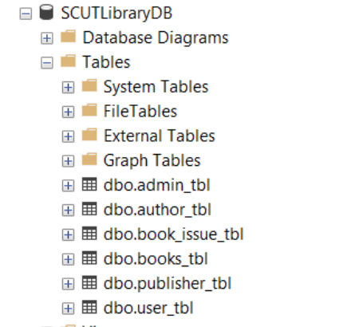

➢**User Table from Database**

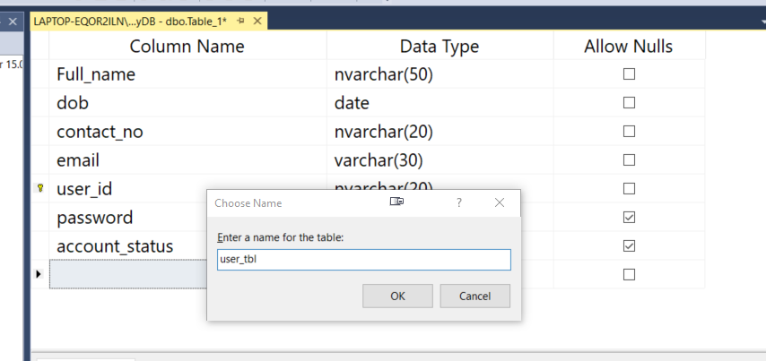

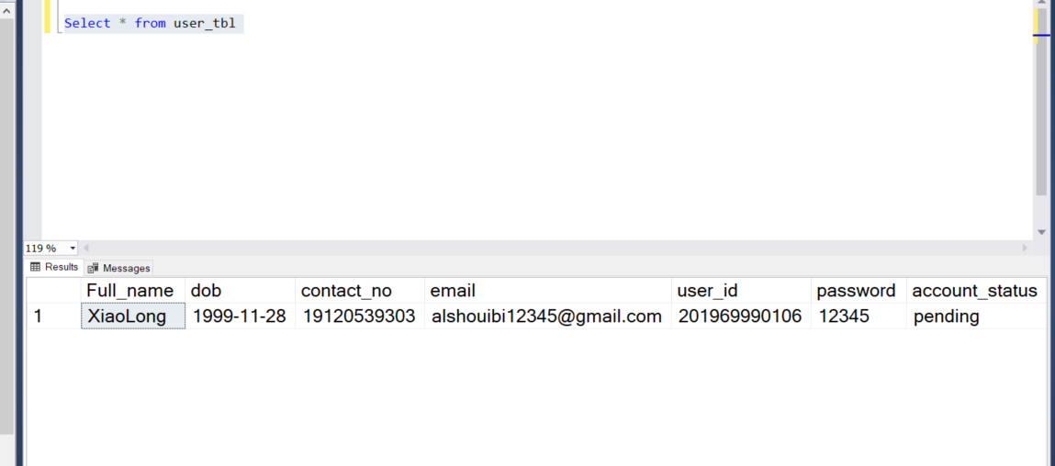

➢ **Admin Table from Database** 

 

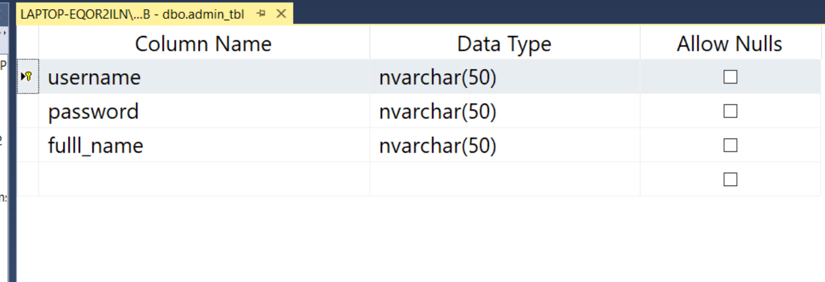

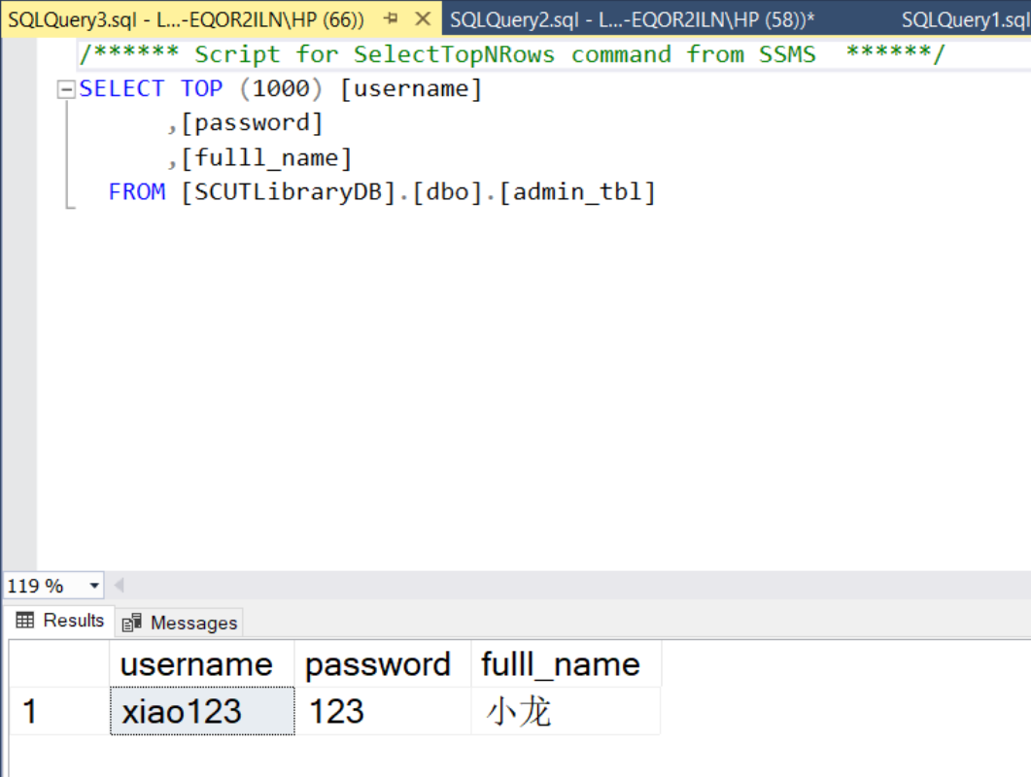

##### ➢ **Author Table from Database**

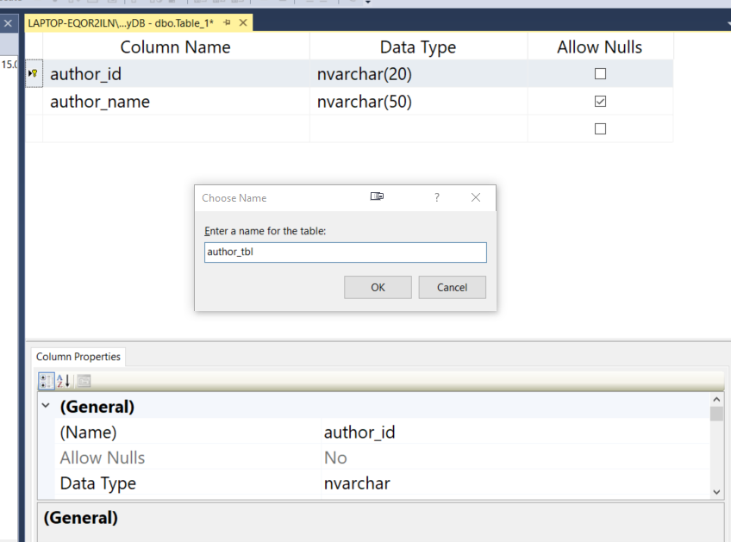

##### 

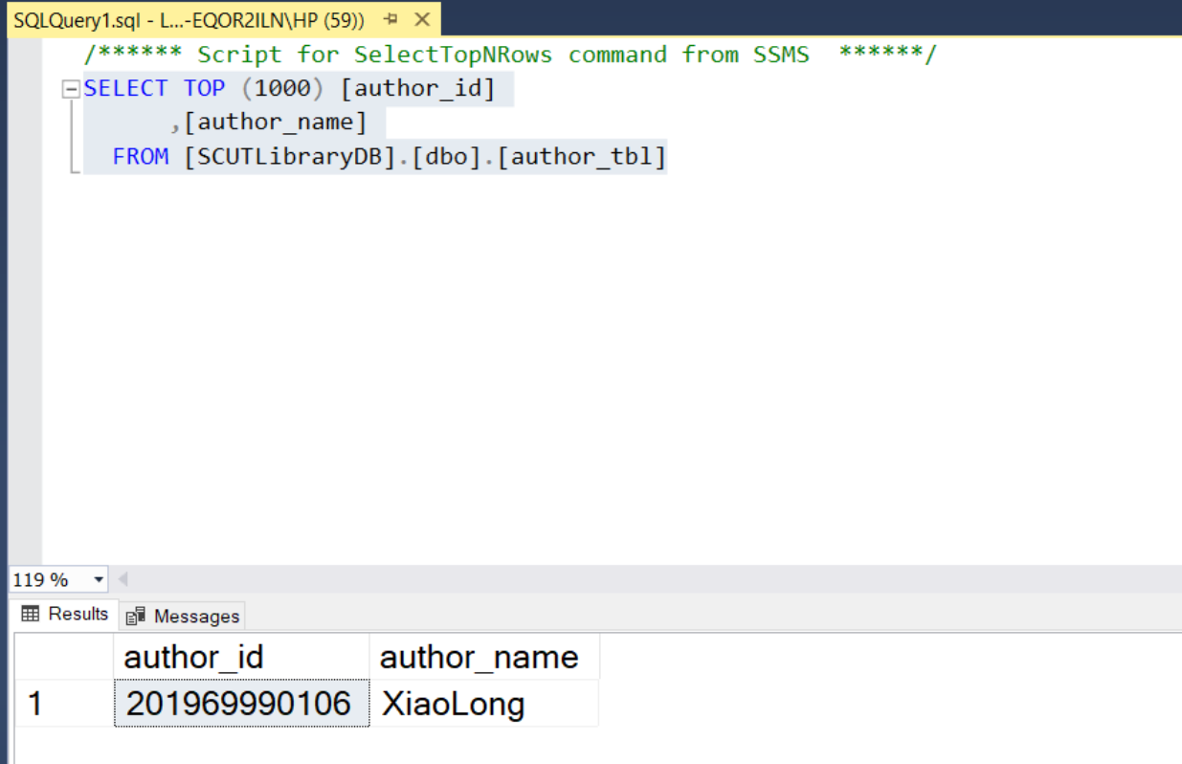

* **Books Table from Database**

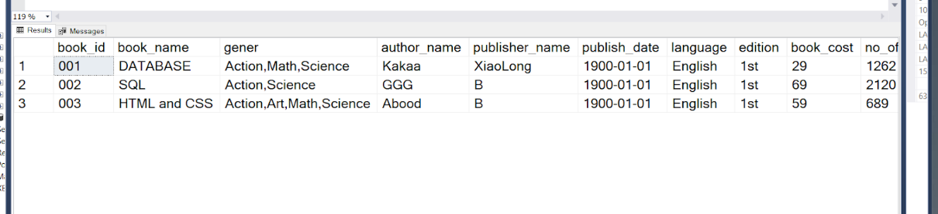

* **Books Issuing Table from Database** 

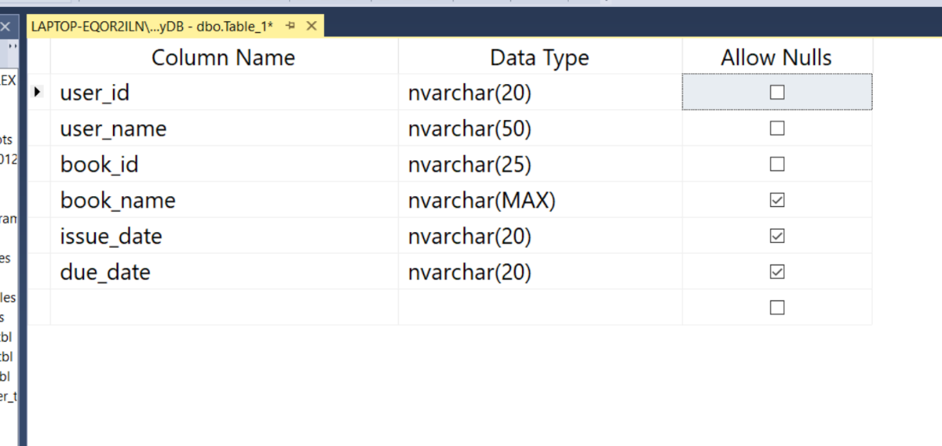

➢**Publisher Table from Database**

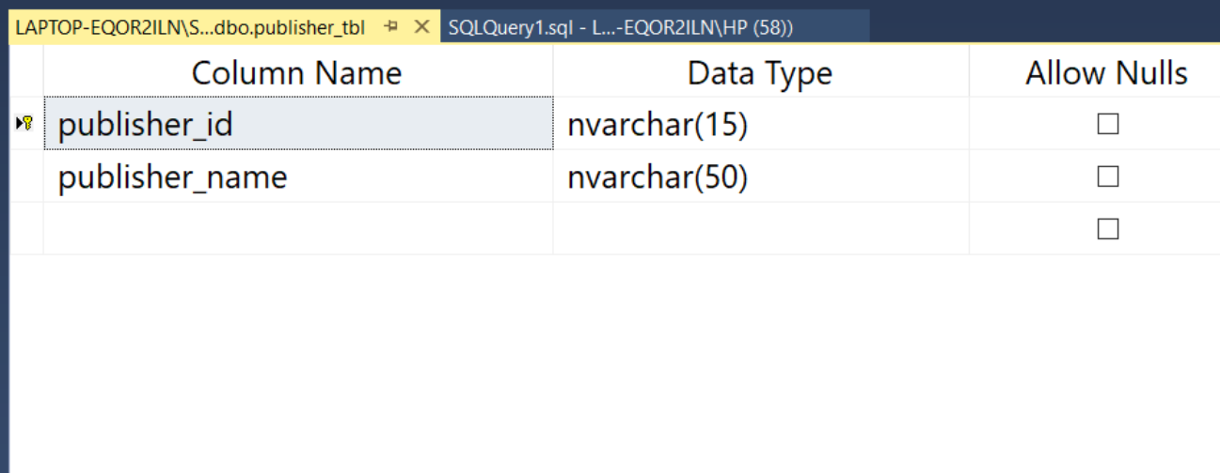

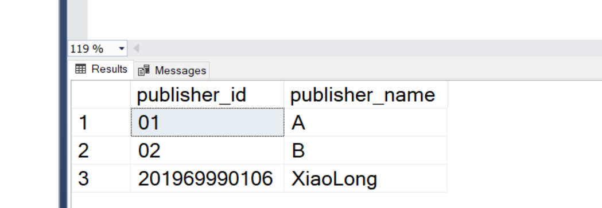

**E-R DIAGRAM**

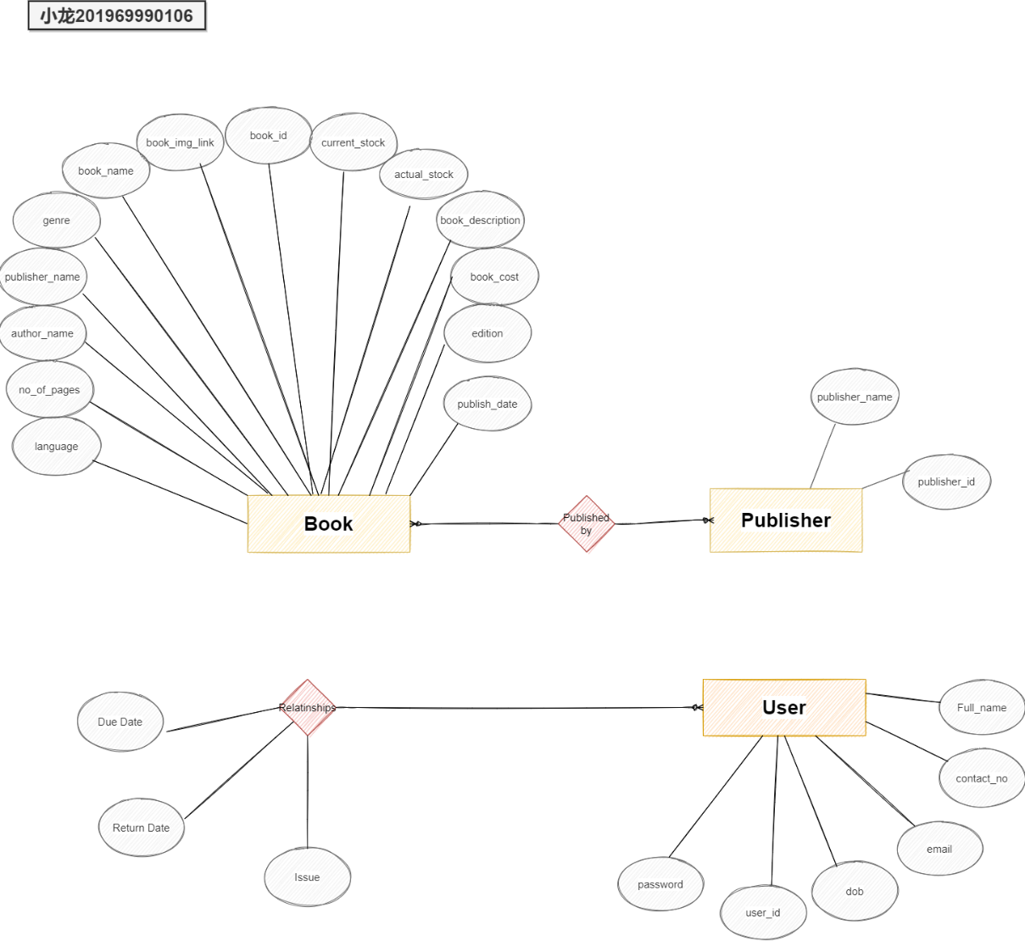

**3.2** **DATA FLOW DIAGRAMS**

##### DATA FLOW DIAGRAM FOR Admin&User LOGIN

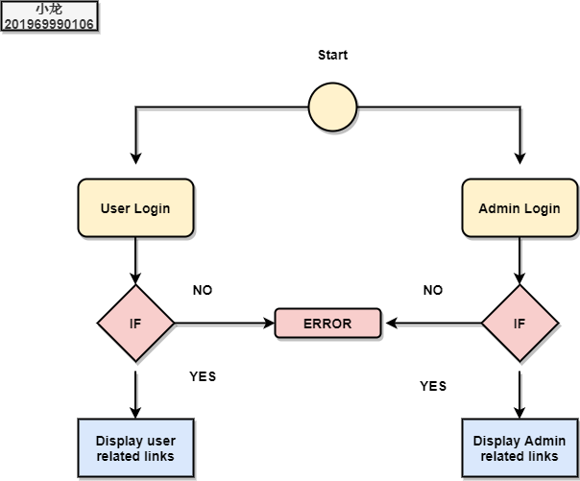

After entering to the home page of the website , Admin can choose the Admin Login option where they are asked to enter username & password , and if he/she is a valid user then a teacher login page will be displayed.

USE CAESE DIAGRAM FOR USER

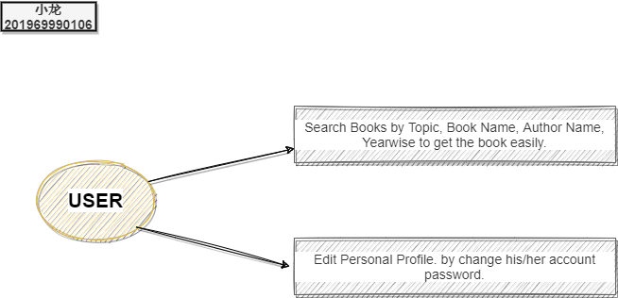

After entering to the home page of the website , student can choose the USER LOGIN option where they are asked to enter username & password , and if he/she is a valid user then a student login page will be displayed.

##### DATA FLOW DIAGRAM FOR USER

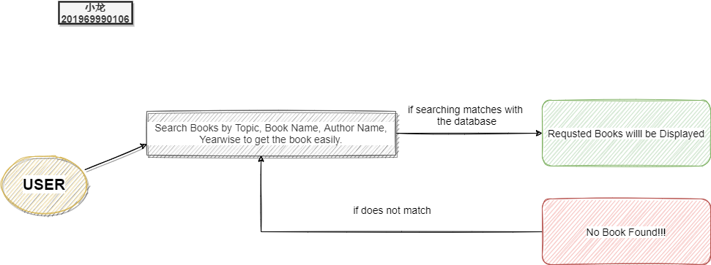

USER CASE DIAGRAM FOR ADMIN

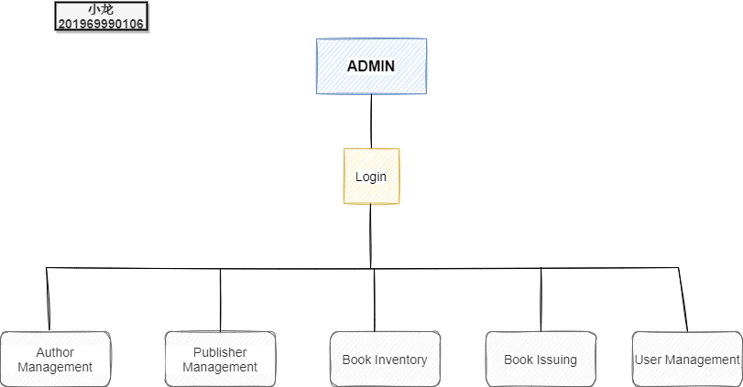

### CHAPTER 4

**SYSTEM IMPLEMENTATION**

**4.1** **Screenshot for homepage** **from User.**

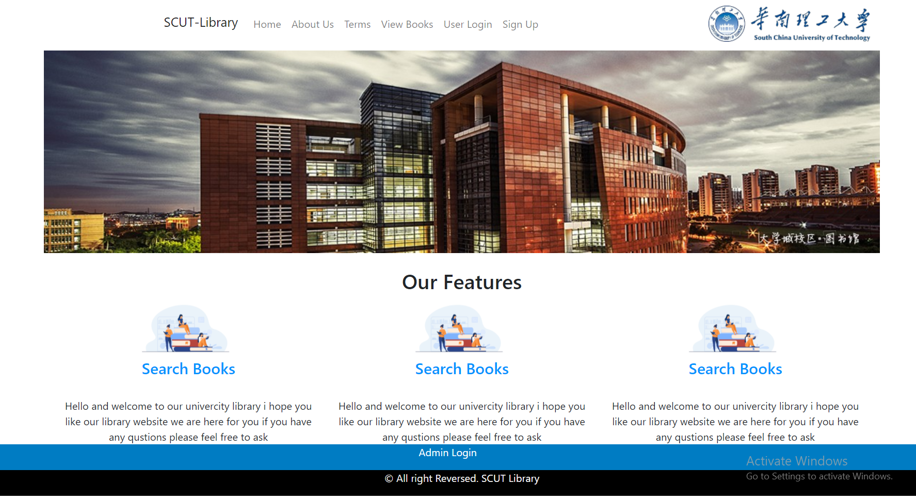

**4.2 Screenshot of user login from User.**

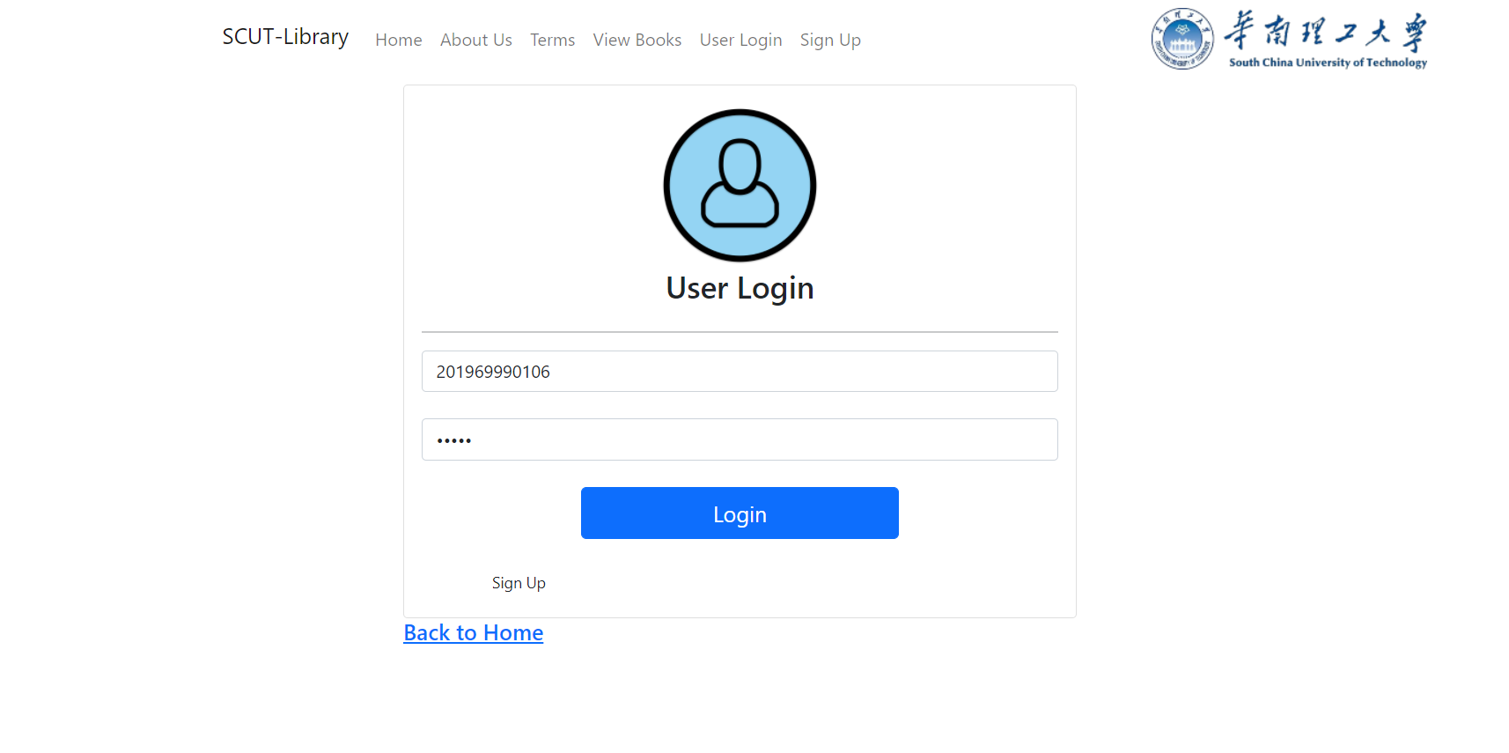

**4.3 Screenshot of user registration from User.**

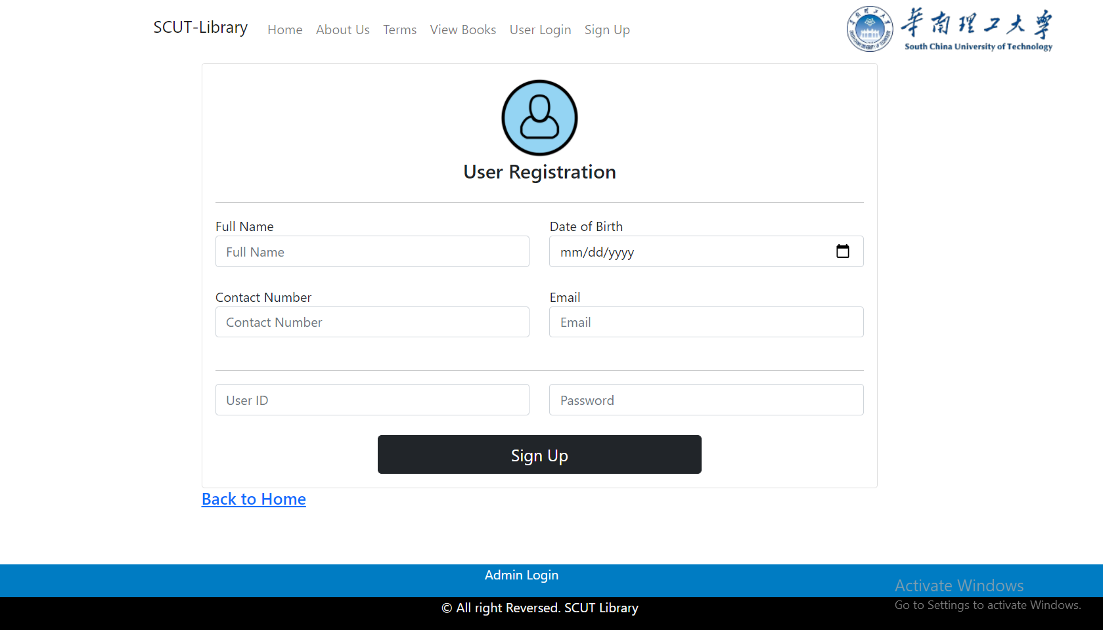

**4.4 Screenshot of book inventory from User.**

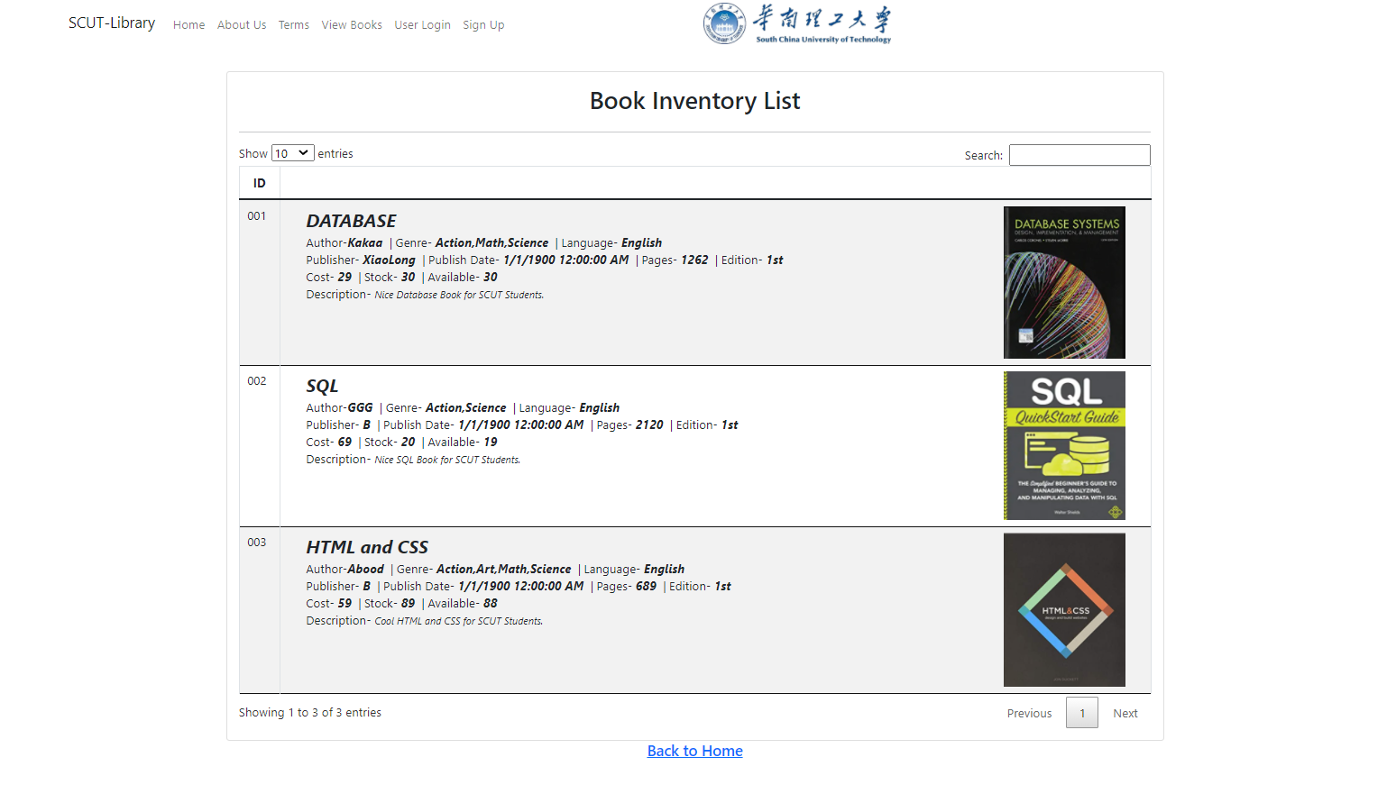

**4.5 Screenshot of user profile from User.**

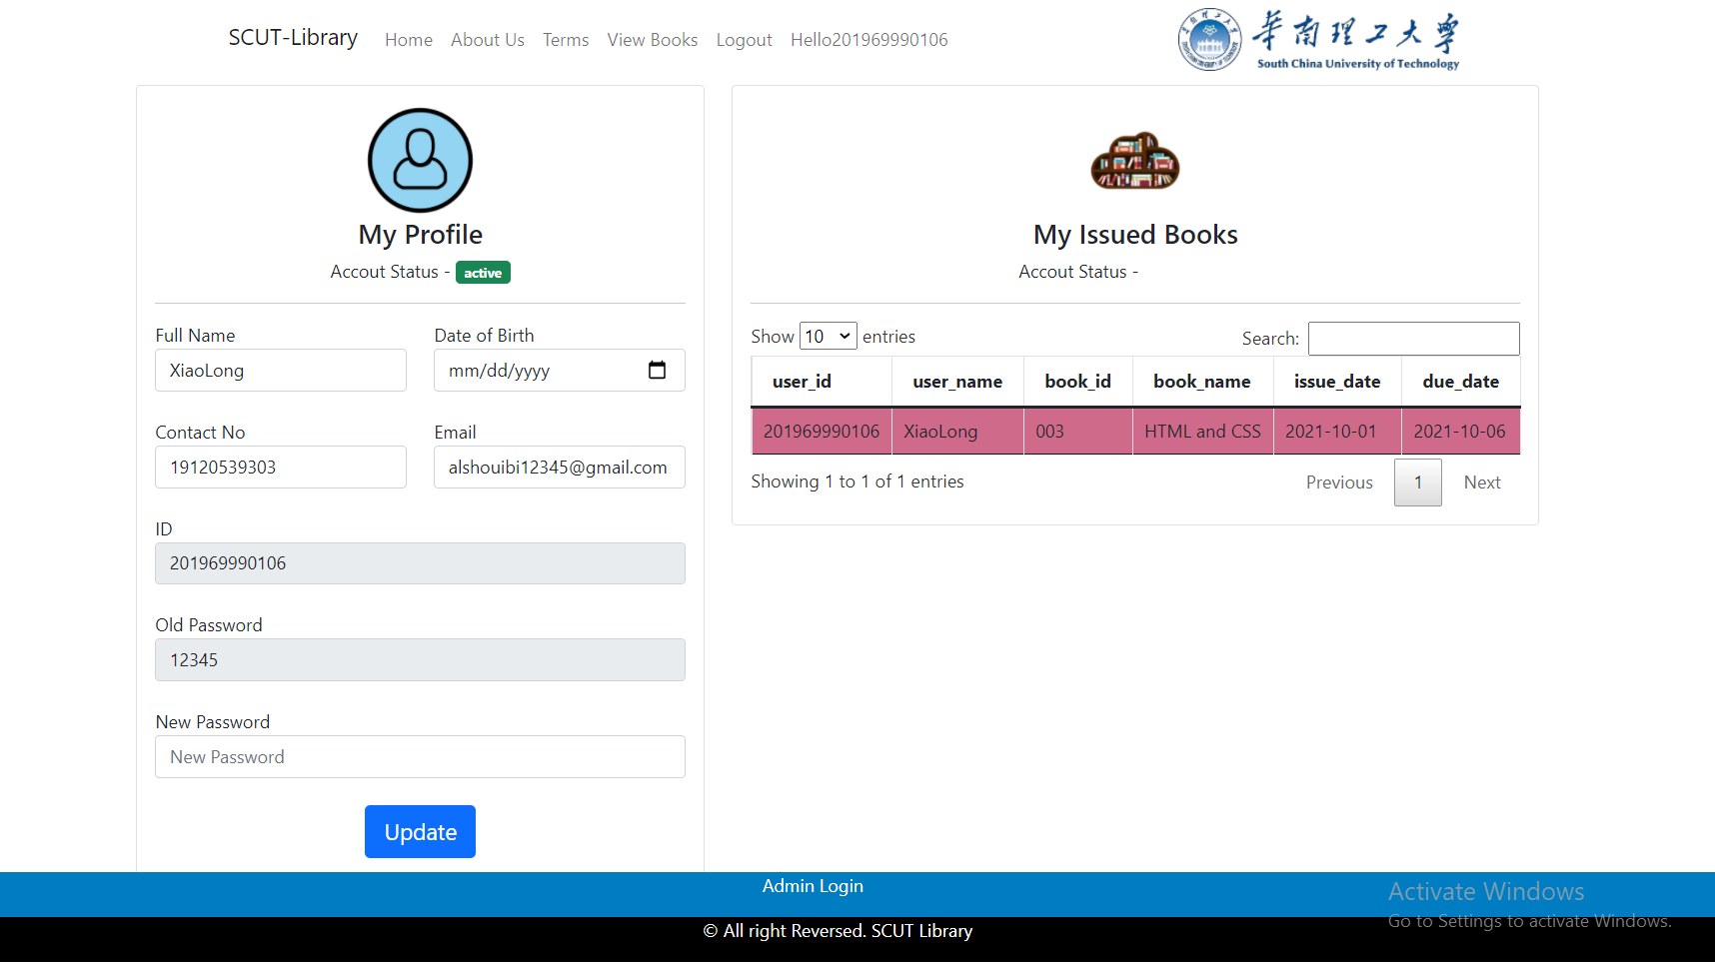

**4.6 Screenshot of homepage from Admin.**

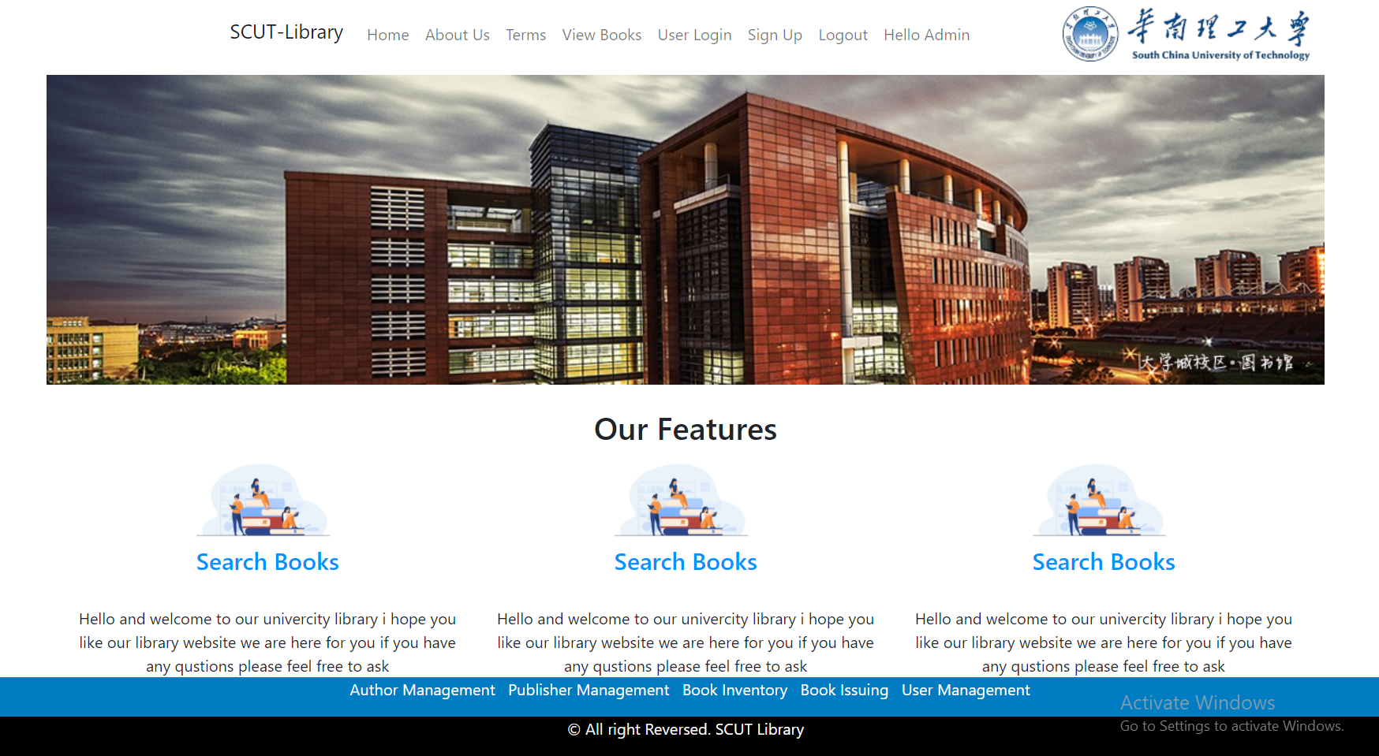

#### 4.7 Screenshot of Author Management from Admin

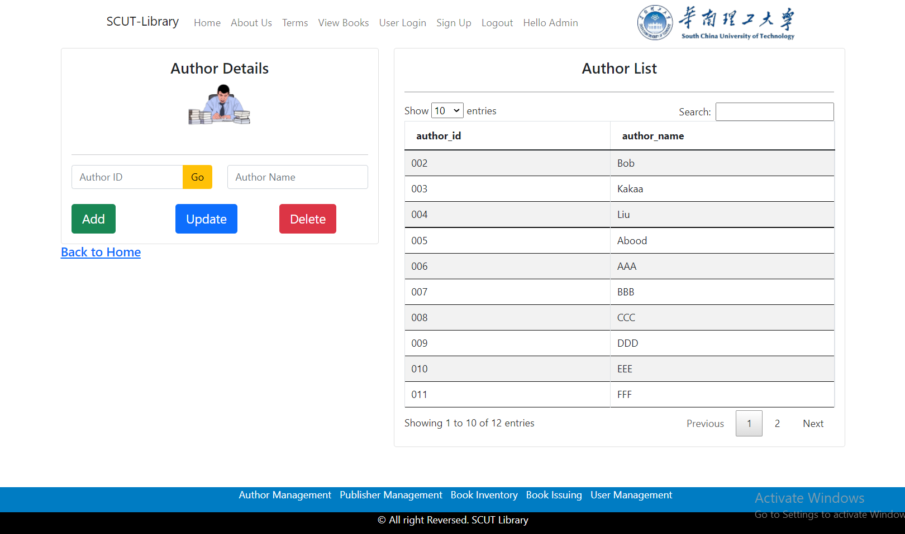

#### 4.8 Screenshot of Publisher Management from admin.

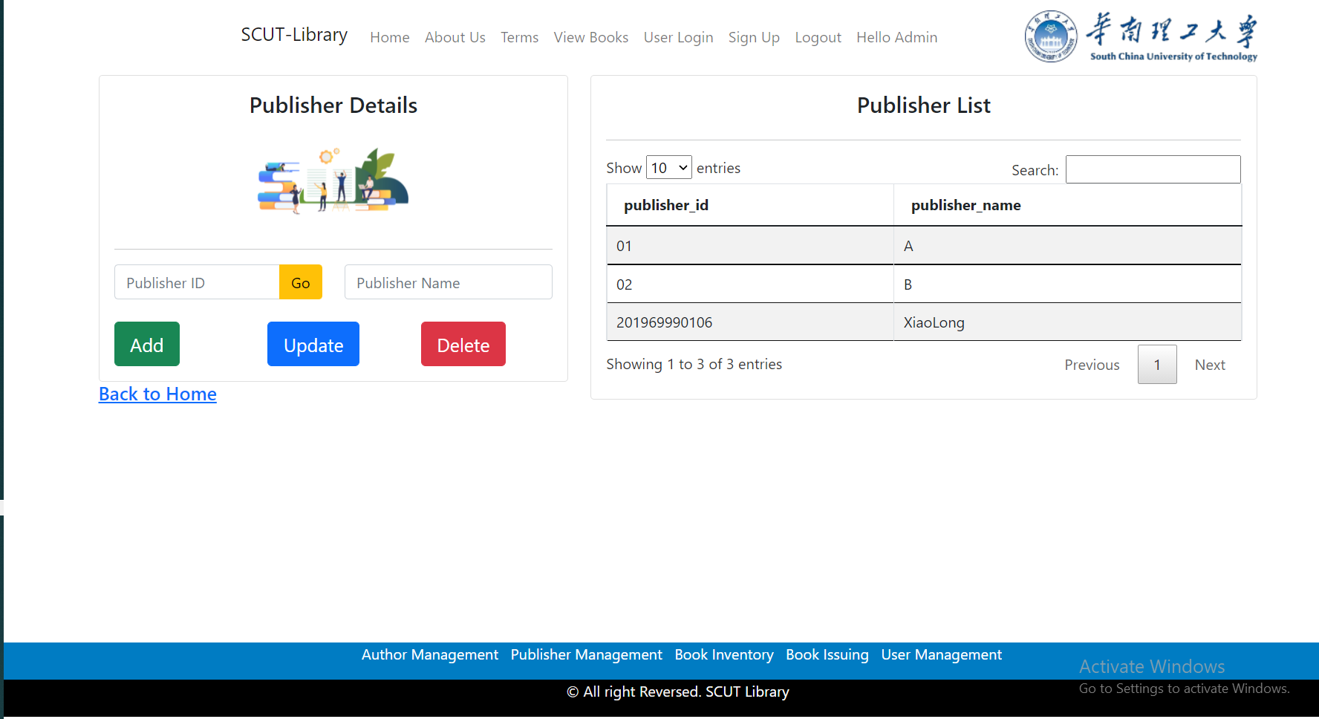

#### 4.9 Screenshot of login for admin

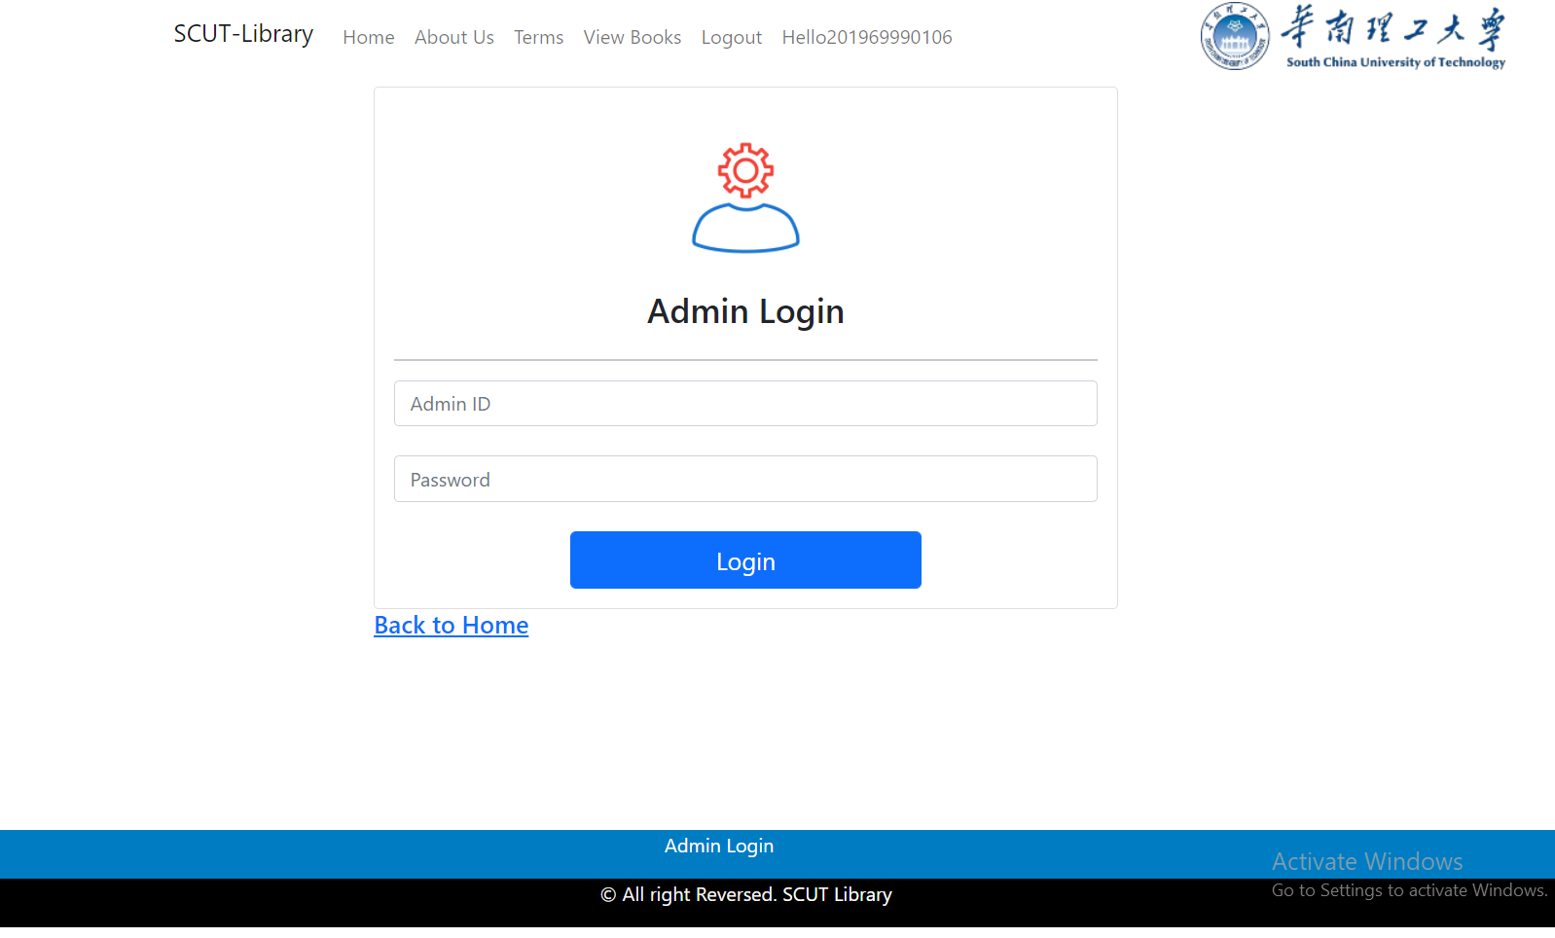

#### 5.0 Screenshot of book issuing from admin .

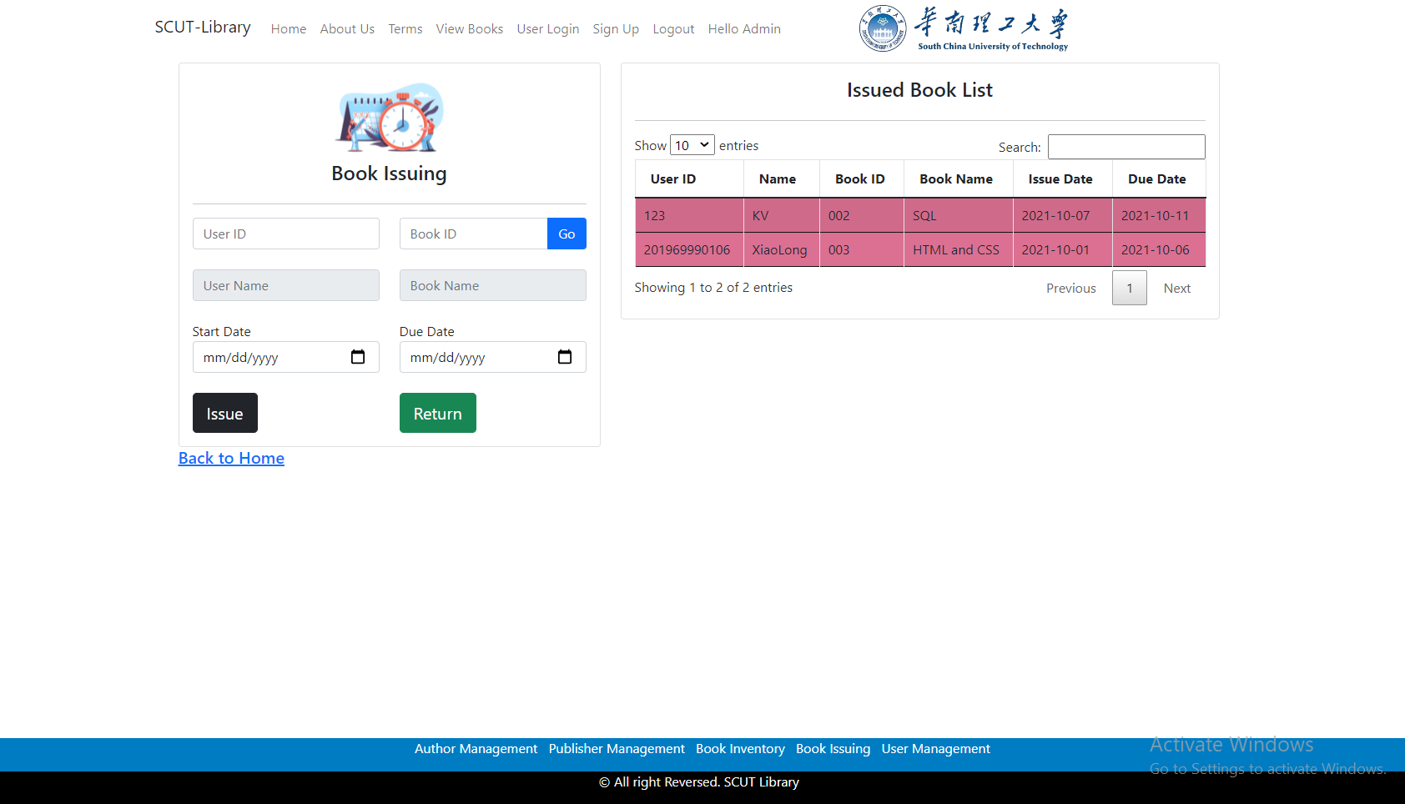

#### 5.1 Screenshot of Book Inventory from admin

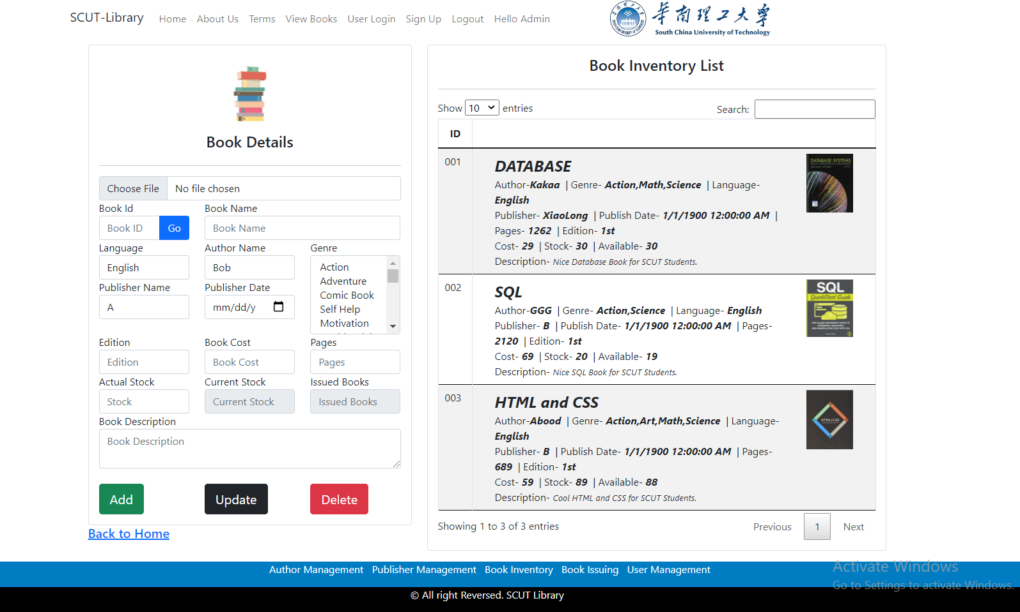

#### 5.2 Screenshot of user mamagement from admin

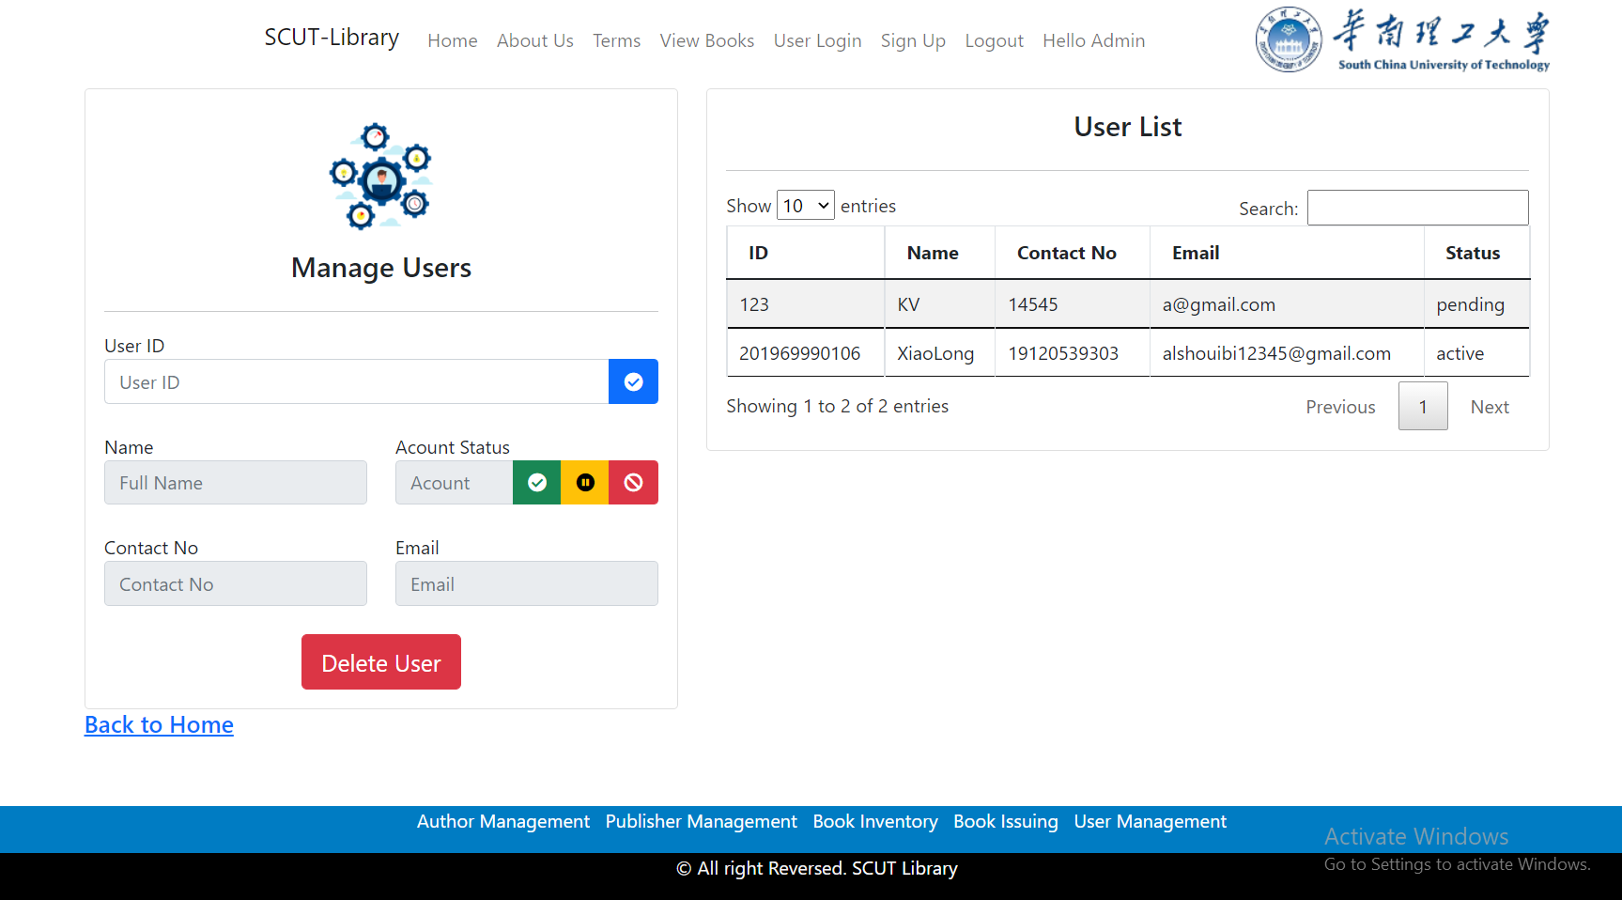

## CHAPTER 5 SYSTEM TESTING

The aim of the system testing process was to determine all defects in the project .The program was subjected to a set of test inputs and various observations were made and based on these observations it will be decided whether the program behaves as expected or not. The

Project went through two levels of testing

1.Unit testing

2.integration testing

### UNIT TESTING

Unit testing is undertaken when a module has been created and succesfully reviewed .In order to test a single module we need to provide a complete environment is besides the module we would require

* The procedures belonging to other modules that the module under test calls 
* Non local data structures that module accesses 

 

* A procedure to call the functions of the module under test with appropriate parameters 

Unit testing was done on each and every module that is described under module description of chapter 4

1. Test For the admin module

* Testing admin login form-This form is used for log in of administrator of the system. In this I enter the username and password if both are correct administration page will open otherwise if any of data is wrong it will get redirected back to the login page and again ask for username and password 

 

* Student account addition- In this section the admin can verify student details from student academinc info and then only add student details to main library database it contains add and delete buttons if user click add button data will be added to student database and if he clicks delete button the student data will be deleted 

 

* Book Addition- Admin can enter details of book and can add the details to the main book table also he can view the books requests . 

 

 

 

1. Test for Student login module

* + Test for Student login Form-This form is used for login of Student .In this I enter the username and password if all these are correct student login page will open otherwise if any of data is wrong it will get redirected back to the login page and again ask for username and password. 

 

* + Test for account creation- This form is used for new account creation when student does not fill the form completely it asks again to fill the whole form when he fill the form fully it gets redirected to page which show waiting for conformation message as his data will be only added by administrator after verification. 

 

### INTEGRATION TESTING

In this type of testing I test various integration of the project module by providing the input

.The primary objective is to test the module interfaces in order to ensure that no errors are occurring when one module invokes the other module.

## CHAPTER 6 CONCLUSION

This website provides a computerized version of library management system which will benefit the students as well as the staff of the library.

It makes entire process online where student can search books, staff can generate reports and do book transactions. It also has a facility for student login where student can login and can see status of books issued as well request for book.



   